A Guide to Thoughtful Funeral Planning

Since purchasing Burdekin Funerals Neville and Lori Boyle have worked hard improving both the building and the service they provide to local families and others throughout the Burdekin.
With over ten years’ experience in the industry, their attention to detail and their genuine concern has helped them remain a keystone member of the community that they serve so well.
Burdekin Funerals has become a place of trust and care where local families receive understanding & thoughtful attention during one of life’s most challenging times - the loss of a loved one.
We understand your needs and feel your pain, aware of just how difficult it is with overbearing grief and other emotions clouding the need to attend your loved one’s personal affairs.
A genuine feeling of ... What should I do now!!

At Burdekin Funerals
We know exactly what to do and help you in this stressful time of your life.!!

THOUGHTFUL FUNERAL PLANNING
When you are grieving the loss of a loved one, the added responsibility of organising the Funeral can be overwhelming.
At Burdekin Funerals we have been helping people for many years, through this distressing time of need, and we are here to ease your burden every step of the way.
This book has been produced to help you through the process of planning a Funeral, together, we can create a meaningful memorial and tribute to your loved one.

This book will answer most questions you have:
- Who do I contact??
- What are my legal responsibilities??
- What immediately needs to be done??
- How do I arrange a Funeral Service??
You may however, have additional questions of your own, if so please call.
Burdekin Funerals on 4783-1608
We will visit you in your home or you can see us in the office and answer any further questions. We can also assist you with answers for the pre-planning guide in the back of the book.
WHEN DEATH OCCURS
There are several important matters to consider.

Death from Natural Causes
If a person dies of natural causes at Home, the first phone call should be to your Doctor who will issue the Cause of Death Certificate.
After this is done and when the family agrees it’s the right time, call us on
(07) 4783-1608 and we will organise for the transfer to our Funeral home.
If death occurs at a Nursing Home, the home will call us on your behalf, and we will arrange for the transfer. You need only to contact us for an appointment and our consultant will visit you and commence planning the funeral with you.
We will arrange and carryout the transfer from the Hospital to our Funeral Home.
Death from Non-Natural Causes
Accidental deaths or deaths by other causes must be reported to the Police who will inform the State Coroner. A person who suffers non-natural death will be taken from the place of death to the nearest mortuary. After the Coroner’s examination, the deceased is released into the care of Burdekin Funerals and then the Funeral may take place.
SOMETHING TO KEEP IN MIND
No matter how the death occurs, one of your first calls should be to Burdekin Funerals, our experience and assistance will take much of the burden from you at a time when grief and other emotions preclude you from focusing on arrangements and other important responsibilities.

PLANNING AND PRE-PLANNING
There is a planning guide in the back of this booklet that you may wish to use to prearrange your own, or another’s funeral. Take time to answer the relevant questions, this will benefit your family by knowing exactly what your wishes are and will assist Burdekin Funerals in making the correct arrangements for your Funeral.
ALLOW YOURSELF TIME
Over the years people have garnered the idea that the Funeral must be held within a specific period of death. This is not the case; you may take your time and proceed at a pace at which you feel comfortable.
Some families desire to put the Funeral behind them as quickly as possible, to them it is seen as a painful experience, and they simply want it to be over.
We encourage you to carefully consider and plan, making sure the arrangements made meet you and your family’s needs.
When deciding on a day & time for the Ceremony allow ample time for:

- A viewing if required  - Preparing an order of service  - Preparation of memory displays | - Writing the Eulogy  - Gathering old photographs  - Relatives that need to travel

ENDURING POWER OF ATTORNEY
As people age, they may appoint an enduring power of attorney to assist in looking after their affairs, while they are still living this person has the legal power to act on their behalf.
However, some believe the nominating enduring power of attorney is the only person to have a final say while ensuring the Funeral arrangements are carried out as wished. This is not so - enduring power of attorney ceases after death, and although this person can be included in the Funeral arrangements it is the appointed executor of the estate who has the final say!!

INFORMATION REQUIRED BY LAW
In Queensland it is compulsory that a deceased person is registered with the Registrar of Births, Deaths and Marriages within 14 days of the occurrence of death. The information needed for this purpose is supplied by the following.
- The Family doctor who completes the cause of Death Certificate
- Family members or a delegate who will provide personal details
- Burdekin Funerals who provide Burial or Cremation particulars

We will assist you with completing the form requiring the personal information and then lodge it with the Registrar of Births, Deaths and Marriages on your behalf.
By completing the information part at the back of this book this will help us to fill out all the relevant details for the Death Certificate.

BURIAL OR CREMATION
The answer to this question will have a bearing when choosing the location for the Funeral and the kind of service. Usually, the wishes of the deceased are known to the family either spoken or in writing, for example a will or pre-arranged funeral plan.
Burial
If there are written instructions from the deceased specifying Burial, then a Cremation cannot take place. Burial is still the traditional interment commonly used and there are several available local cemeteries.
Cremation
Cremation is a respectful dignified process that is preferred by many of today’s families. You may wish more detailed information about the cremation process; we can provide answers to all your questions.
Memorialisation of the Ashes
There are many appropriate ways for dealing with your loved one’s ashes after the Funeral. Burdekin Funerals can help you decide, by providing a range of options that include a plaque of remembrance in a memorial garden wall or scattering the ashes at a location of special significance with the family only, or a Minister or Celebrant in attendance.

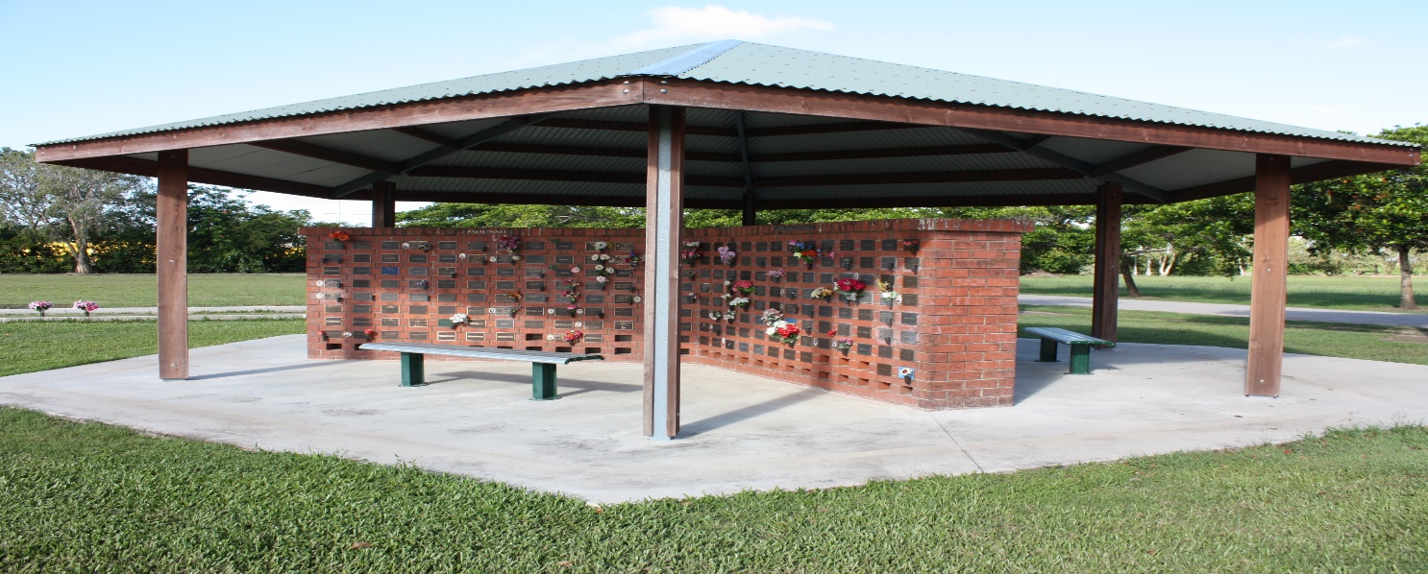
Pre-Purchasing additional Graves
When a death has occurred, and a grave is purchased for a Burial.
It is possible that you may wish to purchase additional grave sites for other family members to be buried alongside at a future point in time.
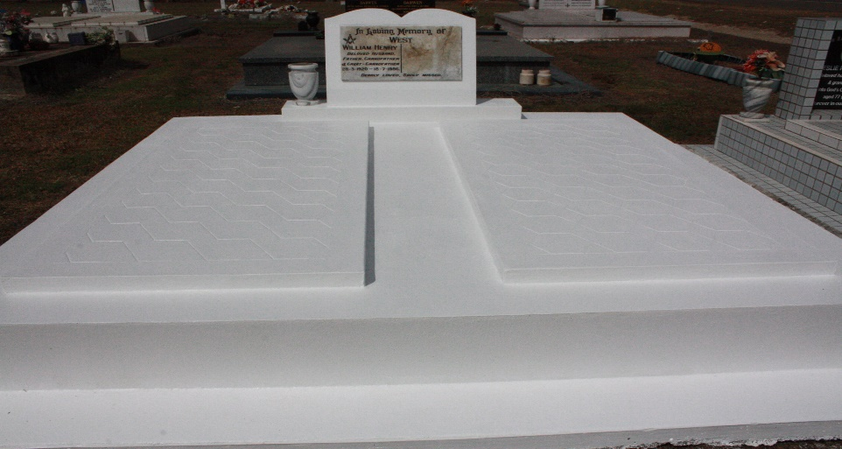

THE FUNERAL VENUE
Funerals can be conducted at many venues; it is important to consider the number of people who may attend. If the person who has died was a member of a church or other place of worship, then that or even your own church could be another appropriate place for the funeral service.
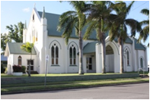
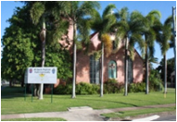
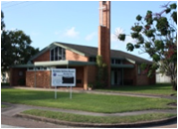
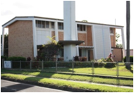
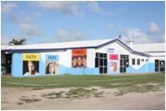

Graveside Lawn Service
You may alternatively choose to have a lawn service at the cemetery of your choice. In this instance you must purchase and have a Plaque for the lawn cemetery within 12 months of your loved one passing. There are many different colours designs available to families and our friendly staff at Burdekin Funerals can help you design your own or you may choose to go with a standard design.
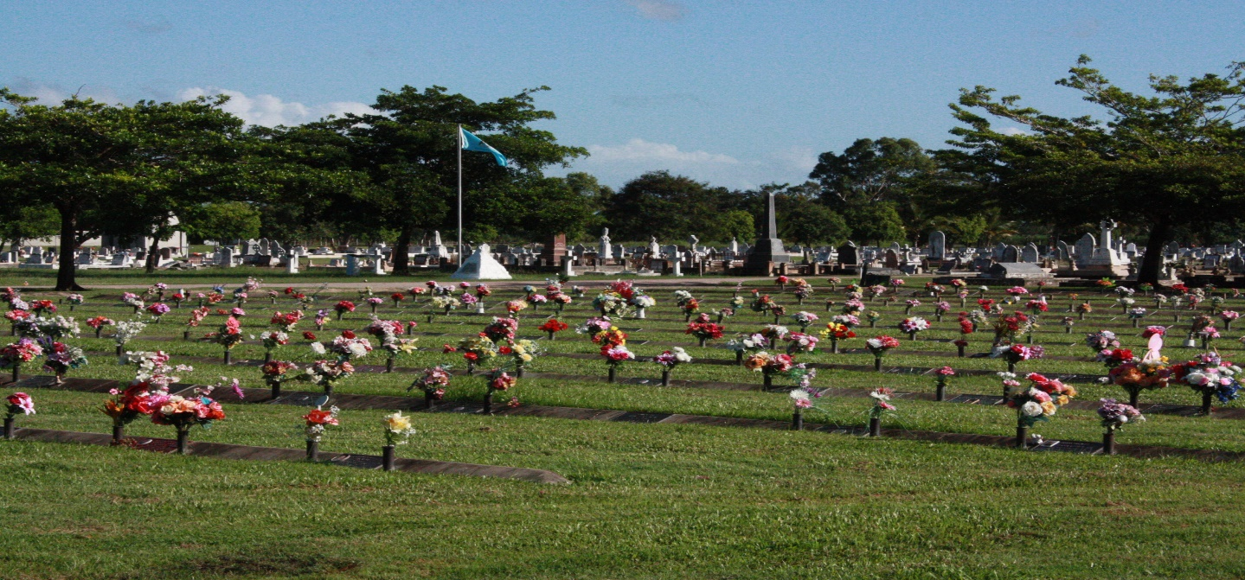
Ayr Lawn Cemetery

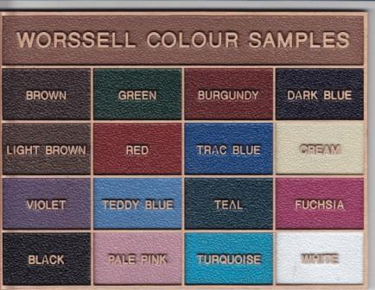
Plaque Colour Samples

THE TYPE OF FUNERAL SERVICE
You may wish to have ...
- A traditional service held in a church or another venue, with a private or public cortege moving to where the burial or committal service is to take place.
- The Funeral service and committal service in a church, or another place with No funeral cortege present. The Funeral Director will remove the coffin usually during the last song or hymn.
- Having the Funeral service and the committal service together at a church, the Crematorium or graveside.
- A memorial or a thanksgiving service where there is No coffin present.
- The type of service you choose may be either public or private.

Remember there is no right or wrong way to plan a funeral, just do what feels right for you and honours the memory of your loved one.

WHO WILL OFFICATE AT THE FUNERAL?
Anyone can officiate at the funeral service, it’s your choice, a Minister of Religion, Civil Celebrant, friend, member or members of your family or if you wish the Funeral Director.
You may like to have your local Minister or Priest lead the service, particularly if you or your loved one has been acquainted with their church and congregation personally. You may not have been to church for many years but would still appreciate a clergy person to officiate at the funeral service, or you may prefer a civil celebrant to lead the service. Whatever your decision, we can arrange this for you.
The person you choose to lead the ceremony will endeavour to meet with you before the service to discuss the life of the person who has passed.
This will ensure that your own personal needs and wants are included in the ceremony.
THE EULOGY
A Loving Tribute to Celebrate a Life
The eulogy is a significant part of the service as it celebrates the life of your loved one, the way they touched your heart and life as well as the lives of others. Writing and delivering the eulogy is an important undertaking, since the eulogy helps the healing process begin for those left behind. The eulogy can be delivered by anyone, a family member, friend, or clergy person. It is best delivered by one who has had close understanding of the deceased. The eulogy may be shared jointly with others contributing words of remembrance, stories, or even poetry and should be a loving, abbreviated tale about the life of your loved one.
PLANNING THE FUNERAL SERVICE
When meeting with us at Burdekin Funerals, discuss any ideas you may have for the service. By adding personal touches, you can create a very special service for the one you cherished, reflecting the unique, exclusive, and exceptional qualities. Here are some suggestions.
- Place some of your loved one’s favourite items on the coffin
- Create a picture board with a montage of memorable photo’s to be displayed.
- Choose a particular hymn or piece of music that may be special to you or your loved one.
- A floral tribute on the coffin may contain flowers that were their favourites or come from their own garden.
- Make order of service cards, with photos, quotes, and poems, available at the funeral service. We can help with these!
- During the service project an audio-visual tribute, (Memories of a Life DVD) images of the person’s life. Again, we can help with this!
- R.S.L., Lions, Rotary, Masonic lodge or other clubs or associations could be asked to participate at the service if your loved one was a member.
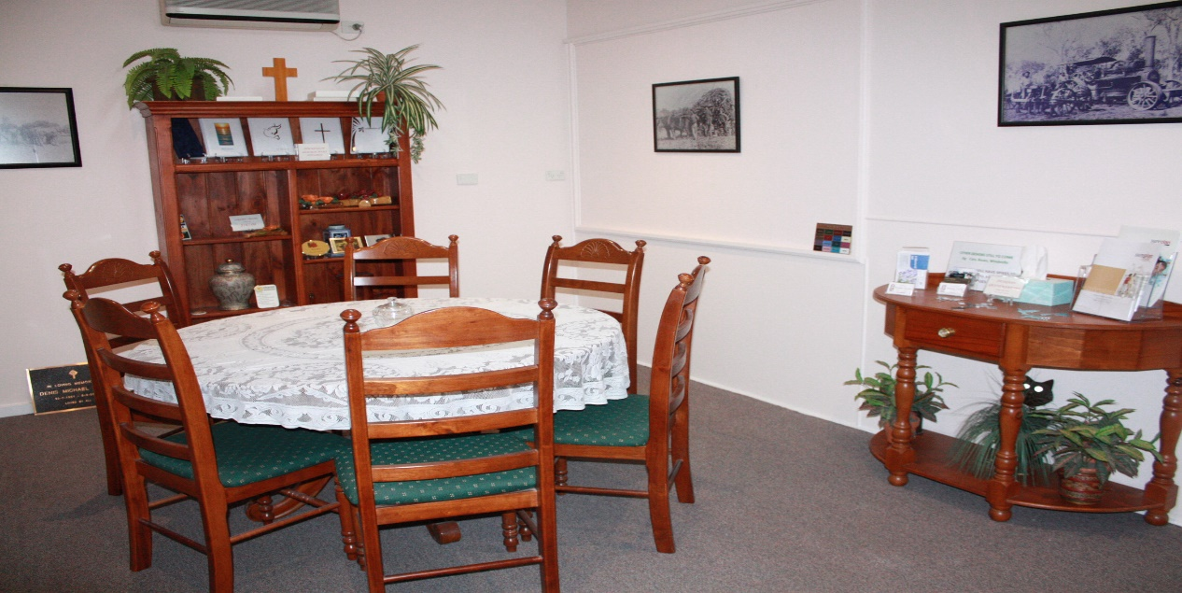
Arrangement Room

WRITING THE FUNERAL NOTICE
The funeral notice informs friends, relatives and the community of the passing of a loved one and conveys to them the details of the funeral service to follow. It is usual to place the funeral notice in the local newspaper, however it can also be published in newspapers from towns where the deceased once lived, worked or was known for an amount of time.
When it comes to writing the funeral notice, we will help you!

VIEWING YOUR LOVED ONE
Viewing your loved one for the last time before the funeral service can be a time of intimate farewell and private cherished memories. In most cases, it also provides healing benefits that can help you move ahead through the grieving process. At Burdekin Funerals we take special care of your loved one and although this is a personal choice, we genuinely urge you to consider this service. We offer this option at NO CHARGE

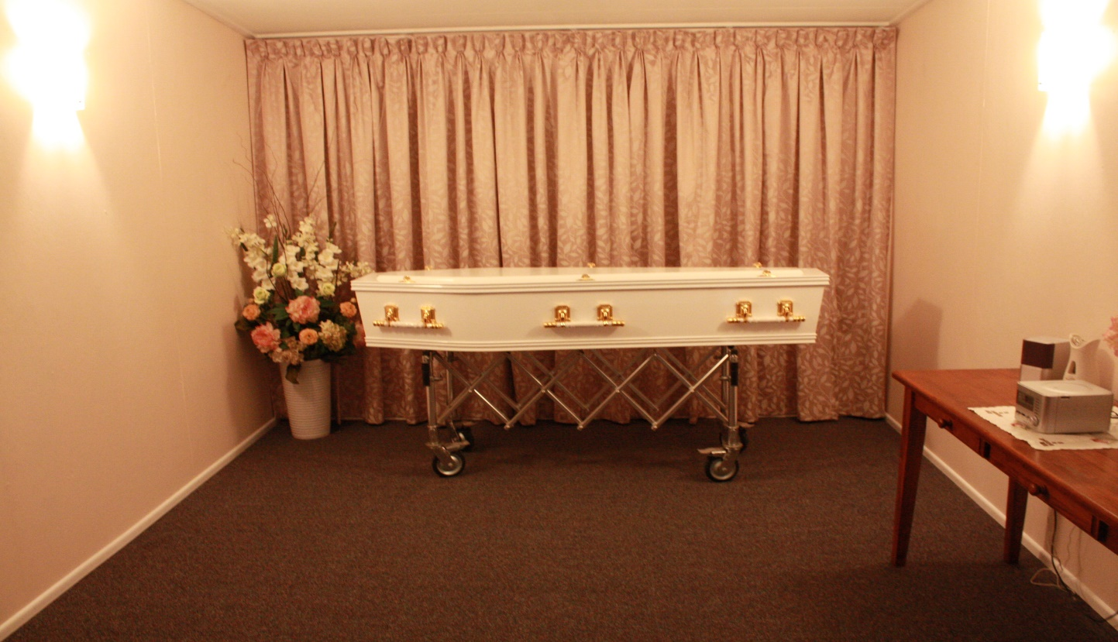
Viewing Room

SPECIALISED DECAL COFFINS
We have an exclusive arrangement of decal coffins available; they can be tailored to your own desire. All we need is for you and your family to agree on the theme, just describe what you require, perhaps supply an illustration or photograph and we will arrange for this to be done on your behalf.
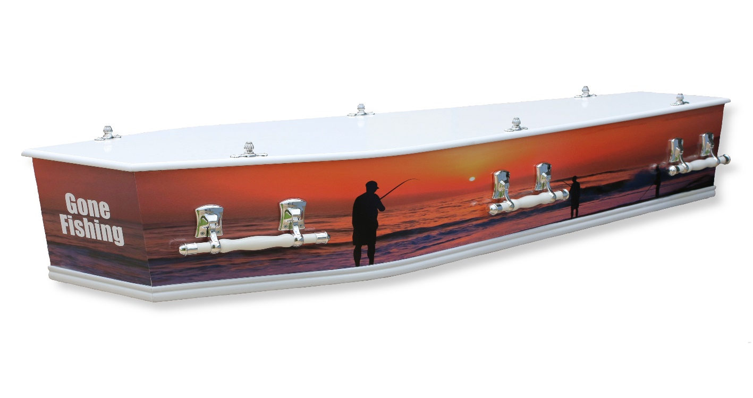
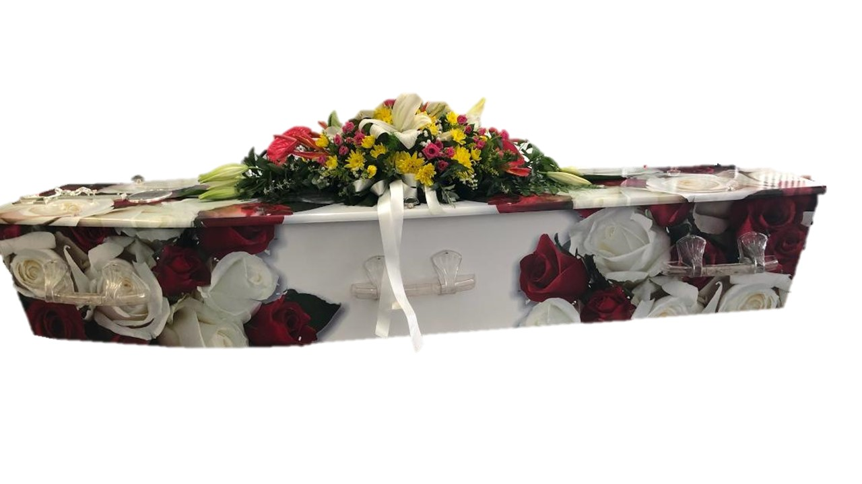

REFRESHMENTS AFTER THE FUNERAL
Once the formal part of the funeral service has ended, you may like to gather with family and friends for refreshments. Funerals are often a time of reunion, this is a time when you, your family, both old and new friends, can share memories, anecdotes and reminisce the life and impact of the one you loved.

You may wish to have refreshments at
- Your own home
- A favourite Restaurant or Cafe
- R.S.L. or a Club Members Hall
- At the Church Hall
- Function room
It is often a good idea to have this mentioned at the end of the service or printed on the back of your service booklets, so friends and family know where this will take place.

THE FUNERAL ACCOUNT
As part of the service of arranging the funeral, the Funeral Director arranges payment on your behalf for the purchase of all goods and services associated with the funeral. These services might typically include cemetery fees, cremation fees, floral tributes, funeral notices, catering services, clergy and musician fees. In this way all expenses including the Funeral Director’s own charges, can be sent to you in one convenient account. If the deceased had a bank account with sufficient funds to cover these costs, the bank in most cases will pay the invoice on presentation of the invoice for direct payment. Although during a time of sadness it may seem awkward and difficult to talk about costs, open and honest discussions are necessary during the planning stages of the funeral. It is important to balance emotional decisions with practical common sense. Burdekin Funerals staff are very sensitive to this matter and will gladly discuss all options with sensitivity and clarity.
AVAILABLE ENTILEMENTS
Centrelink-
The Centrelink bereavement payment is to assist with settling financial affairs associated with expenses incurred by the deceased prior to death. This may include the extension of existing payments and/or a sum paid to a surviving partner, carer, or parent of a young child, assisting with the changed financial circumstances caused by death of a person who was a pensioner, long term allowee, a child or carer recipient.
Department of Veterans’ Affairs-
If the deceased was an-ex-service person, it will be necessary to contact the Department of Veterans’ Affairs and ask about eligibility to claim a Veterans’ funeral benefit. If entitled, an application form will be sent to you for completion, and once returned, payment can be made into the deceased veteran’s estate.

Checklist
WHO TO NOTIFY
There are a number of people and organisations that may need to be contacted when a death occurs in the family. As a helpful guide, this checklist may assist you in finalising your loved ones affairs as this will ensure you can get the help and advice you need.
• | Accident Insurance | • | Accountant
• | Banks | • | Australian Taxation Office
• | Car Insurance | • | Building Societies
• | Centrelink General Inquiries | • | Age Pension Enquiries
• | Chemist | • | Church or Religious Organisation
• | Clubs, Organisations and Assoc | • | Companies (eg Directorships)
• | Credit Card Providers | • | Credit Unions
• | Dentist | • | Department Veteran Affairs
• | Doctor, Specialist or Hospital | • | Electoral Office
• | Electricity | • | Employer/former Employer
• | Executor of Will  Friendly Society | • | Financial Institutions  Loan Companies
• | Gas | • | Gardening Services
• | Home & Contents Insurance | • | Household Help
• | Home Nursing Help | • | Life Insurance
 | Home Deliivery Service eg Milk, Paper, Magazine Subscriptions) | • | Meals on Wheels
• | Home Nursing Help | • | Optometrist
• | Landlord | • | Private Heath Benefit Fund
• | Local Council | • | Service Organisations (eg Library)
• | Medicare | • | Solicitor or Public Trustee
• | Post Office | • | Telephone Company
• | School or College | • | Vehicle Insurance
• | Superannuation Company | • | Veterinary Surgeon
• | Trade Unions or Professional Assoc | • | Social Worker
• | Vehicle Ownership Transfer

Details of Deceased:
First Name: ...........................................................................
Surname: ..............................................................................
Sex: Male П Female П Date of Death: .................................
Date of Birth: .................................. Age: ..........................
Place of Death: ..............................................................................
Residential Address: ......................................................................
Usual Occupation during working life: ..........................................
Retired at date of death: Yes П No П
Place of Birth: .................................................................................
Town/City: ......................................................................................
State and Country: ..........................................................................
If born overseas, in what year did the deceased first arrive in Australia?...............
What Nationality are they? …………………
Was the deceased Aboriginal or Torres Strait Islander?
П No П Yes, Aboriginal origin П Yes, Torres Strait Islander origin

The relationship state of the deceased at time of death:
П Never Married П Married П Divorced П Widowed
П Registered Relationship П De Facto П Unknown

Marriage Details (if applicable)
Marriages or registered relationships of the deceased:
1 Town / City: .................................. State / Country: .................................
Deceased’s age at date of Marriage: ........................................................
Name of Wife / Husband / Maiden Name: ................................................
2 Town / City: .................................. State / Country: ..................................
Deceased’s age at date of Marriage: ........................................................
Name of Wife / Husband / Maiden Name: ................................................
Children of Deceased: (Include legally adopted children)
FULL NAME: ....................................... Date of Birth ...................... AGE … M/F
FULL NAME: ....................................... Date of Birth ...................... AGE … M/F
FULL NAME: ....................................... Date of Birth ...................... AGE … M/F
FULL NAME: ....................................... Date of Birth ...................... AGE … M/F
FULL NAME: ....................................... Date of Birth ...................... AGE … M/F
Father of Deceased:
First Name: ............................................................................................................
Surname: ................................................................................................................
Occupation during work life: .................................................................................
Mother of Deceased:
First Name: ............................................................................................................
Maiden Name: ........................................................................................................
Occupation during work life: .................................................................................

Your Name: .............................................................................................................
Current Residential Address: ..................................................................................
.................................................................................................................................
State: .................................................................. Post Code: ..................................
Phone Number: ........................................ Mobile: ....................................
Place of Service: Church Crematorium Plantation Park Other
Cemetery: Ayr Home Hill Other
New grave OR ........................................................
Section: Lawn Vault Monumental
Crematorium: Family member to collect Columbarium Wall
RSL Commemoration: Yes П No П Service No: ....................
Arrangement: Requested songs Pall Bearers
Flowers Flowers Colour Paper Notice
DVD Memorial Book Service Booklets
..................................................................................................................................................................................................................................................................................................................................................................................................................................................................................................................................................................................................................................................................................................................................................................................................................................................................................................................................................................................................................................................................................................................................................................................................................................................................................................................................................................................................................................................................
Today’s Date: .................../ ................./....................

Additional Notes or Information:
.............................................................................................................................................................................................................................................................................................................................................................................................................................................................................................................................................................................................................................................................................................................................................................................................................................................................................................................................................................................................................................................................................................................................................................................................................................................................................................................................................................................................................................................................................................................................................................................................................................................................................................................................................................................................................................................................................................................................................................................................................................................................................................................................................................................................................................................................................................................................................................................................................................................................................................................................................................................................................................................................................................................................................................................................................................................................................................................................................................................................................................................................................................................................................................................................................................................................................................................................................................................................................................................................................................................................................................................................................................................................................................................................................................................................................................................................................................

